**DAILY ONLINE ACTIVITIES SUMMARY**

|  |  |  |  |  |  |  |  |  |
| --- | --- | --- | --- | --- | --- | --- | --- | --- |
| **Date:** | 28-05-2020 | | | | | **Name:** | SINDHU N | |
| **Sem & Sec** | 6th and B | | | | | **USN:** | 4AL17CS094 | |
| **Online Test Summary** | | | | | | | | |
| **Subject** | | OS (2ND IA TEST) | | | | | | |
| **Max. Marks** | | 30 | | **Score** | | | 24 | |
| **Certification Course Summary** | | | | | | | | |
| **Course** | PYTHON FOR MACHINE LEARNING | | | | | | | |
| **Certificate Provider** | | | Greatlearning academy | | **Duration** | | | 1 WEEK |
| **Coding Challenges** | | | | | | | | |
| **Problem Statement:** GIVEN 2 PROBLEMS | | | | | | | | |
| **Status:** Completed | | | | | | | | |
| **Uploaded the report in Github** | | | | | Yes | | | |
| **If yes Repository name** | | | | | https://github.com/lsindhungowda/Daily-report | | | |
| **Uploaded the report in slack** | | | | | Sindhu N  Yes, I uploaded the report in slack | | | |

**SNAPSHOT OF SECOND IA TEST MARKS:**

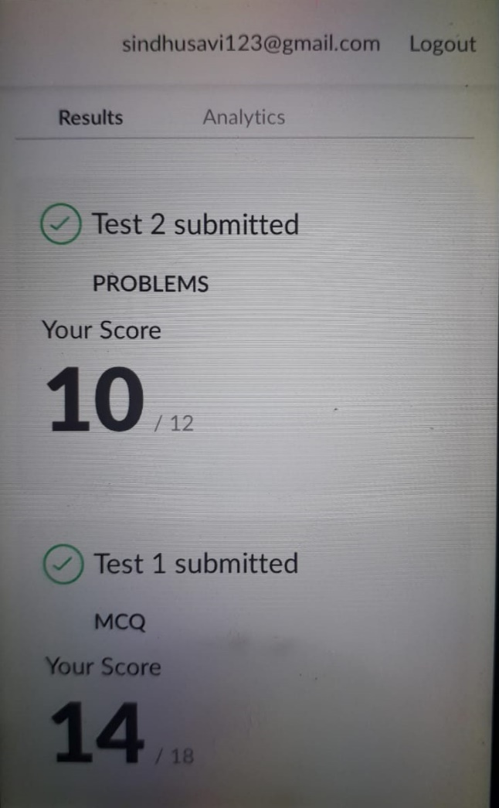

**SNAPSHOT OF ONLINE CERTIFICATION COURSE:**

**SCREENSHOT1:**

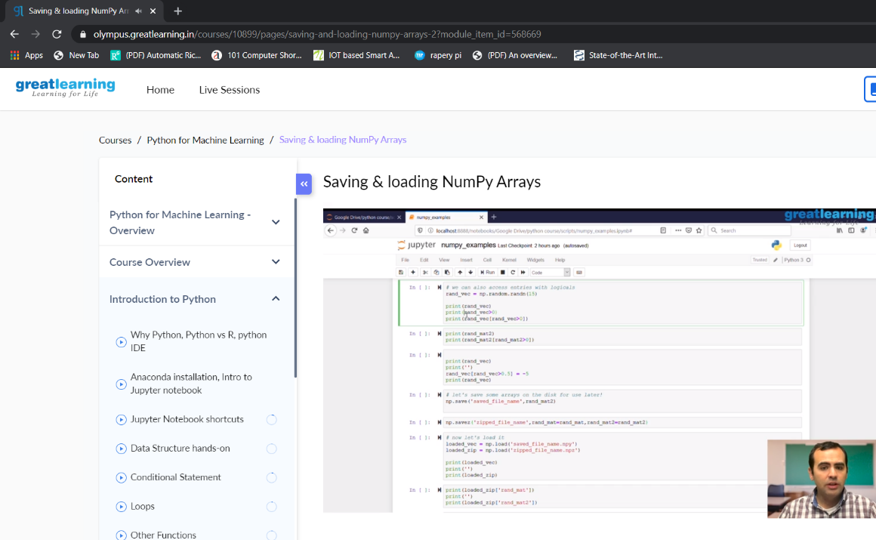

**SCREENSHOT2:**

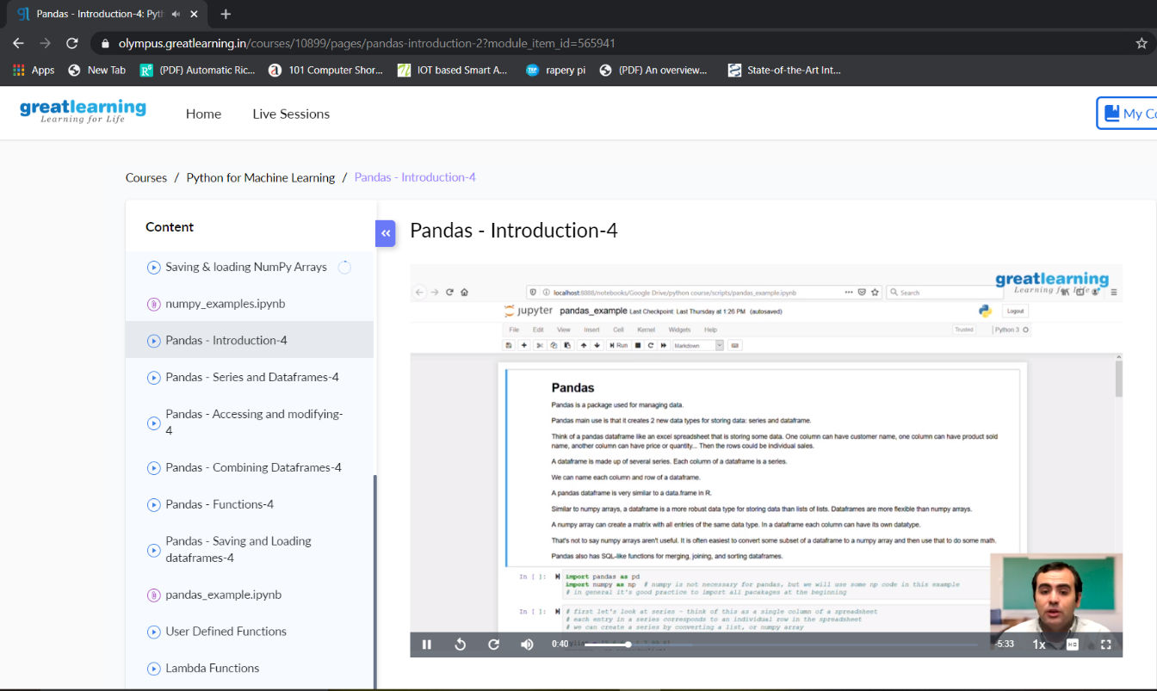

**SNAPSHOT OF ONLINE CODING:**

**PYTHON PROGRAM 1:**

A digital root is the recursive sum of all the digits in a number. Given n, take the sum of the digits of n. If that value has more than one digit, continue reducing in this way until a single-digit number is produced. This is only applicable to the natural numbers.

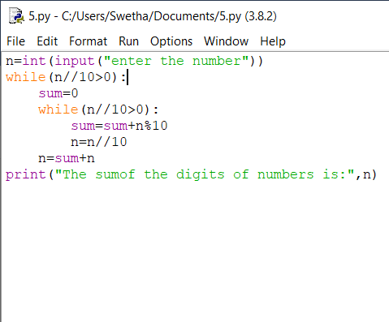

**OUTPUT:**

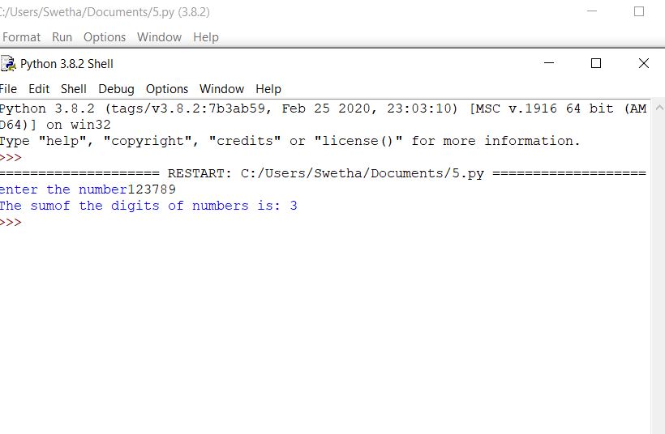

**C++ PROGRAM:**

The rules for reducing the array are:  
#The first and last element say X and Y are chosen and removed from the array arr[].  
#The values X and Y are added. Z = X + Y.  
#Insert the value of Z % K into the array arr[] at the position ((N/2) + 1)th position, where N denotes the current length of the array.  
Examples:

Input: N = 5, arr[] = {1, 2, 3, 4, 5}, K = 7  
Output: 1

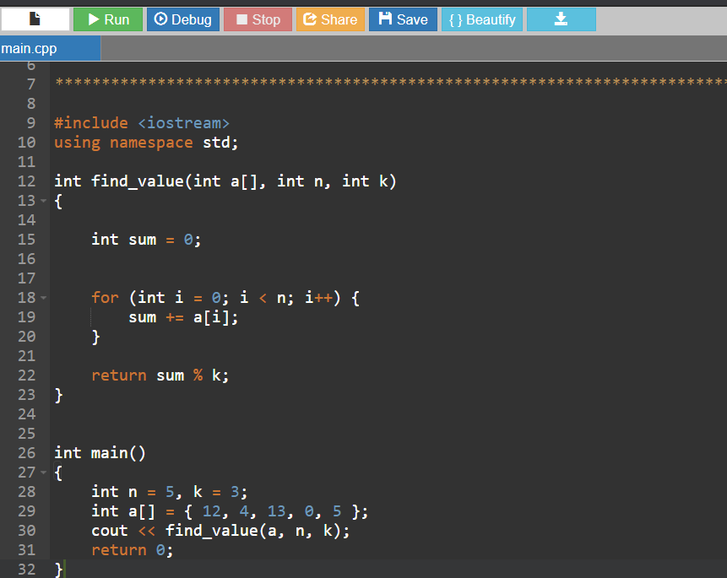

**OUTPUT:**

